**HOMEWORK WEEK2**

**MEMBERS**

**JANNA**

**ADRIANNA**

**CHEY**

**SOLYNE**

This week’s homework will be purely Project based. You need to work as a group and the homework will be submitted by one of the members of your group. List the other members of your group in the document, so that your instructor can mark every student.

1. Your group needs to decide what kind of project you are going to work on and lock in your decision.
2. You need to submit a free style paper that describes your project on a high level. Please cover the following questions:
3. **What are you building?**
4. **What does it do or what kind of problem does it solve?**
5. **What are key features of your system?**
6. **Provide a sample architecture diagram of your system** (you can use PPT with squares and circles to demonstrate a simplified flow of your system) For example:

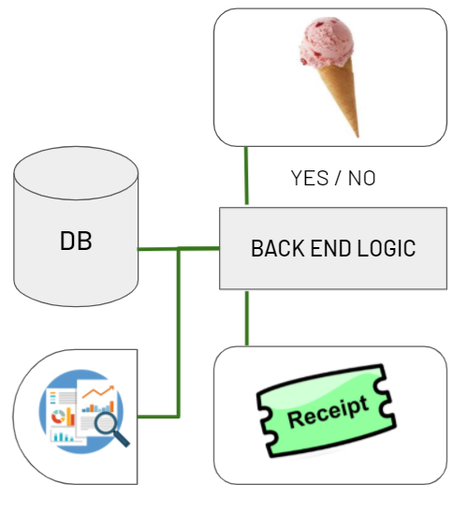

1. **Describe the team approach to the project work**: how are you planning to distribute the workload, how are you managing your code, how are you planning to test your system.

Q.1 What are you building?

Tinder for Rents program.

Q.2 What does it do or what kind of problem does it solve?

We are creating this program to help people search for properties for rent, in Tinder style. Tinder is a popular dating app that enables people to search for someone they like. The only action required from the user is to swipe left or right. Left for dislike, and right for heart. Our program is intended to do the same - simple and minimum interaction with quick results.

What problem is your program going to solve?

The aim of the Tinder for Rents program is to help users search for properties for rent, quickly and easily. These days, people have less time to juggle anything else outside of their full time job, studies and other commitments. This program will simplify and somewhat expedite the process of searching for a property to rent by narrowing down the suggested ‘matched properties’ to the user. In return, this will save the user some time on searching, and more time for leisure, or viewing the property.

How does the program work?

The main function of the program will be very similar to Tinder. Tinder is a very popular dating app, that help users search for a possible match, according to their defined preferences.

Tinder for Rents will have 5 pages.

1st Page: Home page

-> The Homepage will be as the name suggests. This will have the basic information of the program.

2nd Page: Matching page

-> The Matching page will be as the name suggests. This will contain a series of suggested properties for rent, based from the preferences defined by the user. In a way, these properties are ‘matched’ with the user’s needs and wants.

In this page, program will display a list of properties matched with the users’ criteria. The properties will be displayed with brief information such as the location, the price pcm, and the picture. At the bottom of the screen, two buttons will be displayed too - ‘X’ button and ‘Heart’ button. If the user likes the property they see from the list, they will be able to swipe left to remove the property from the suggested list, or swipe right to add the property onto the favourites page.

3rd Page: Favourites

-> The favourites page will be as the name suggests. This will contain the ‘liked’ properties of the user, from the program’s suggested properties. Here, the user will be able to further narrow down their search by viewing the full information of the properties they had liked.

4th Page: Profile

-> The profile page will contain the personal information and some of the criteria for their search. The user will be able to change the criteria for their search whenever. The only limit is they won’t be able to change the email address and name they have entered upon signing up to the program.

5th Page: Login/Sign Up

-> This page will display a short form where they will be asked to sign in or sign up. If they click sign in, the program will display the form with the sign in information such as the email address/user name, and password. At the bottom of this, they user can also choose ‘Forgot Password’ or ‘Forgot email address/username’.

If the user clicks the sign up button, an application form will be displayed by the program. Here, they will be asked to enter their personal details and searching criteria for the property they wish to rent.

Q.3 What are key features of your system?

There are 3 key features of our system/program.

1. Simplicity: clicking mechanism
2. Convenience: Auto-match and ability to narrow down the searching criteria
3. Record the data in a database

Q.4 Provide a sample architecture diagram of your system.

API

* We still have to identify which one we need to use

Front end

-HTML

Dummy database

To choose when we swiping left to right

Python backend

-API

PROJECT REPORT

-visual diagram

**Steps on how the programs will look like**

**First step sign in/ login**

**Then swipe left right on houses**

**add to favourites**

Q.5 Describe the team approach to the project work.

To organise the code we are working on separately for this project, we have set up a git repository on GitHub. We originally identified key areas in the first week and dispersed them among the team members. We split into two groups of two. Solyne and Adrianna: HTML, Flask, and GitHub are the assigned tasks.

The project report, that will include the visual diagram, API, and database, will be completed by Janna and Chey.

At the end of the week, we will talk about the upcoming assignments.

As we create our code, we will each create a program for testing. we will also designate each other as reviewers when creating a pull request on GitHub and we have set up a Trello board.

Using github we will manage the code

As previously stated we will distribute workload via Trello:

We will break tasks into small parts and add roles for each person

We will also do weekly meeting to see how everyone is getting on with the workload

We use zoom to have our weekly meeting